# CS-340 Client/Server Development

**Dakota Keyes**

**7-2 README**

**Background**

Grazioso Salvare-the client has paired with a non-profit organization that operates five local animal shelters in the Austin, Texas region. Grazioso Salvare is actively working to identify rescue dogs from local shelters that would be good candidates for training. These candidate dogs, which must meet certain specifications and criteria, would be trained as search-and-rescue animals to help rescue animals or humans that are often in life-threatening conditions.

Grazioso uses specific characteristics and attributes that they utilize to categorize possible candidates. For example, dogs that are not over the age of two make better candidates for training purposes. Furthermore, some breeds are more efficient and effective for search-and-rescue than others.

Within the search criteria, there are a few categories of rescue types which include water rescue, mountain/wilderness rescue, and individual/disaster rescue.

The client has access to existing data provided by the partnered animal shelters. However, Grazioso is requisitioning a software application to quickly and efficiently search, identify, and categorize available dogs in the region.

**Purpose & Usage**

This software application allows the user to interact with the MongoDB database to access the animal shelter data *“aac_shelter_outcomes.csv”* provided by the client company and its partner. The database created from the csv file in MongoDB allows the user to manipulate, search, filter, and perform a variety of other methods on the data. The Animal Shelter application provides different options to search the animal database using specific filters/keywords.

The UI dashboard was developed with principles of UX (User-Experience) in mind, such as visual design, and intuitive usability, and as a priority. The dashboard we created, enables users to visualize and interact with the database, accessing, searching, filtering, categorizing, sorting, and refining, the data through search criteria.

## Motivation

*This is a short description of the motivation behind the creation and maintenance of the project. This should explain* ***why*** *the project exists.*

The creation of the Animal Shelter application was fueled by a need to *efficiently* search and categorize dogs for rescue training. Using the information provided by the shelters, it was possible to create a database to fulfill the client’s needs.

*Manually searching through the data files to identify candidates for training is* ***not*** *realistic, efficient, or effective, and would take endless hours to complete.*

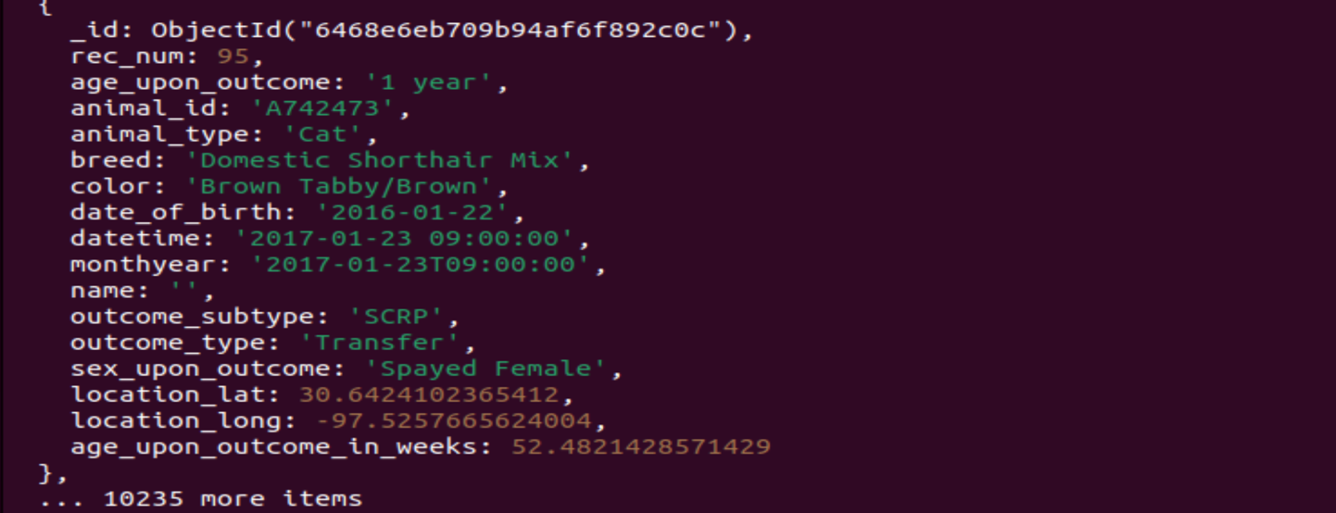

Working with the existing data from the animal shelters, Grazioso Salvare wants to identify and categorize available dogs which meet certain criteria. To meet the requirements of this project, MongoDB provides different methods of categorizing and identifying dogs based on specific parameters. CRUD operations will be necessary to quickly search through already existing databases, and we have been tasked with creating methods for CRUD operations to efficiently categorize search-and-rescue candidates from animal shelters.

**Rationale**

The model component of development for this software application is MongoDB. MongoDB’s installation and setup is simple and easy. Python provides portability, for programs to run on different platforms. This simplicity benefits both the configuration and deployment process for integrating MongoDB and Python. MongoDB utilizes a flexible and dynamic architecture, unlike SQL, there is no need to define schemas. Python is syntactically simple, which improves productivity and makes maintaining and updating this software much quicker. Because MongoDB accesses data from the RAM performance enhances and data availability is increased (*TechVidvan*, 2021).

## INSTRUCTIONS & STEPS TAKEN

## Installation and Configurations

**Requirements** **Resources**

|  |  |
| --- | --- |
| **Python3** | <https://www.python.org/downloads/> |
| **MongoDB** | <https://www.mongodb.com> (Installation) |
| **Jupyter Notebook** | <https://jupyter.org> |

For this software application, you will need a current version of Python, I have Python 3.8.3, but earlier releases will work too.

*\*To download Python simply click the link and select the OS and version.* <https://www.python.org/downloads/>

You can also check which version you have installed from the command prompt (Windows) or terminal (Mac & Linux).

* [Check Python version on the command line: --version, -V, -VV](https://note.nkmk.me/en/python-sys-platform-version-info/" \l "check-python-version-on-the-command-line-version-v-vv)
* [Check Python version in the script: sys, platform](https://note.nkmk.me/en/python-sys-platform-version-info/#check-python-version-in-the-script-sys-platform)

You must have access to the MongoDB so that can be downloaded on your computer.

<https://www.mongodb.com>

For help downloading MongoDB follow the link below.

<https://docs.mongodb.com/manual/installation/>

You will need to install PyMongo (the driver for MongoDB) to interact with MongoDB using Python.

You can install the library using **pip install pymongo**

For the next step, you will need access to Jupyter Notebook (or if you have a different Python IDE you prefer) but for this project we utilized Jupyter Notebook.

[**https://jupyter.org**](https://jupyter.org)

From here, you have the option to install Jupyter onto your device or use the browser to create and execute notebooks.

**STEPS TAKEN**

**Reproducing Project**

**Database Commands - Using MongoImport & Authenticating Login for Users**

Inside the Animal Shelter zipped file, there is a CSV file containing the data set needed to import the animal information into the database. Start by accessing your Terminal Window (Mac & Linux) or Command Prompt [cmd.exe] for Windows.

*\*\*These instructions are for Linux based OS, but Linux command line prompts can be executed on Windows 10 and 11 without the need for a virtual machine, with the Windows Subsystem for Linux 2. Mac uses a similar shell so most commands should execute on either shell.*

First, we must import the CSV file using the command below.

mongoimport --port <PORT#> --db AAC --collection animals ./aac_shelter_outcomes.csv

This will import the CSV file into the specified database.

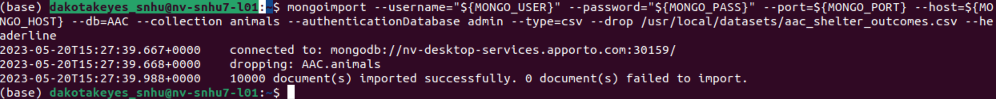

The shell will return a successful import response if the documents were imported successfully.

Next, using the mongo shell, we will create an administrator account and a user account which will ensure proper authentication into the database. To create an administrator account, type the following code.db.createUser ({

user: "admin",

pwd: passwordPrompt(),

roles: [{ role: "userAdminAnyDatabase", db: "admin" }, “readAnyDatabase"]

})

Using a similar command, we will now create a user for the AAC database.

db.createUser ({

user: "aacuser",

pwd: passwordPrompt(),

roles: [{ role: "readWrite", db: "AAC" }]

})

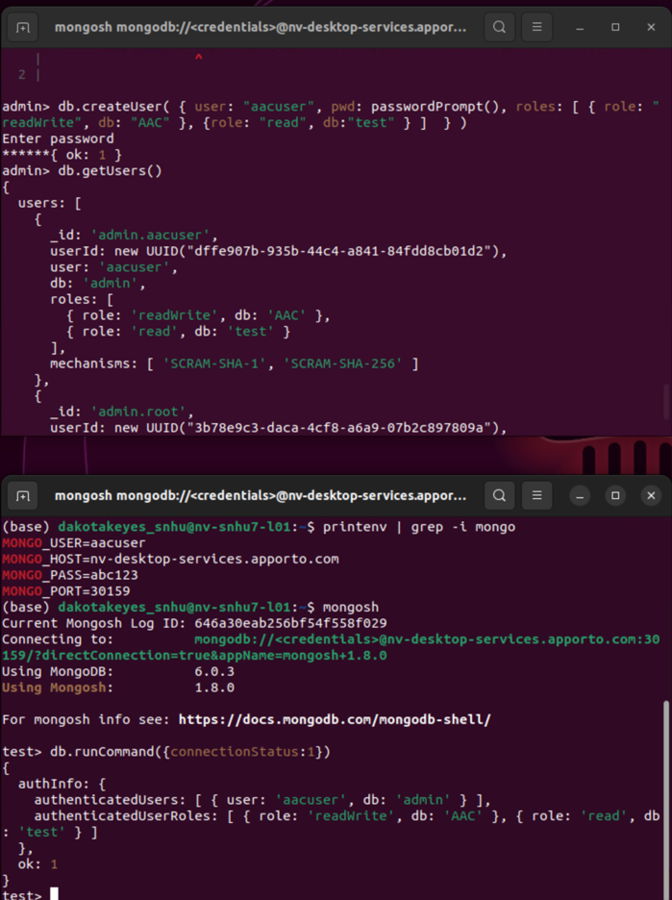

After creating the admin and aacuser account, you can verify if your account was created successfully.

MONGO_USER=aacuser

MONGO_PASS=<password you selected>

printenv | grep -i mongo

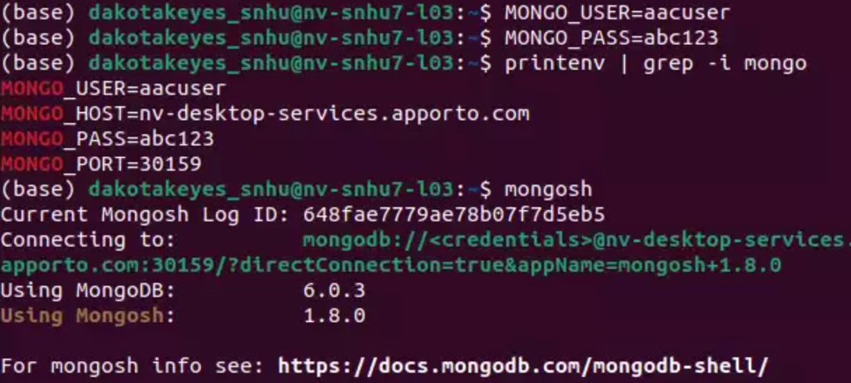

**CRUD Module in Python**

The CRUD methods in the Python module are basic operations to access and manipulate the data within the MongoDB. In order to Create, Read, Update, or Delete any of the data within the database these CRUD functions are necessary. CRUD methods are basic methods for interacting with any data in a non-relational database like MongoDB.

Create method that queries for document(s) from a specified MongoDB database (“AAC”) and specified collection (“animals”). Input should also be key/value lookup pair to use with MongoDB driver find API call.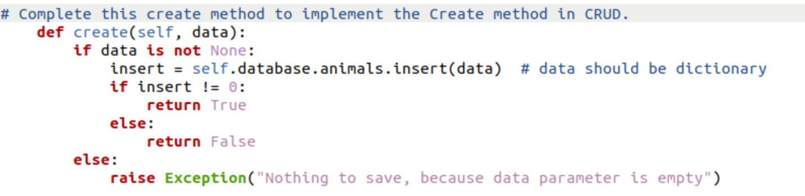

Read method that queries for document(s) from a specified MongoDB database (“AAC”) and specified collection (“animals”). Input should also be key/value lookup pair to use with MongoDB driver find API call. Result in cursor if successful, else error message.

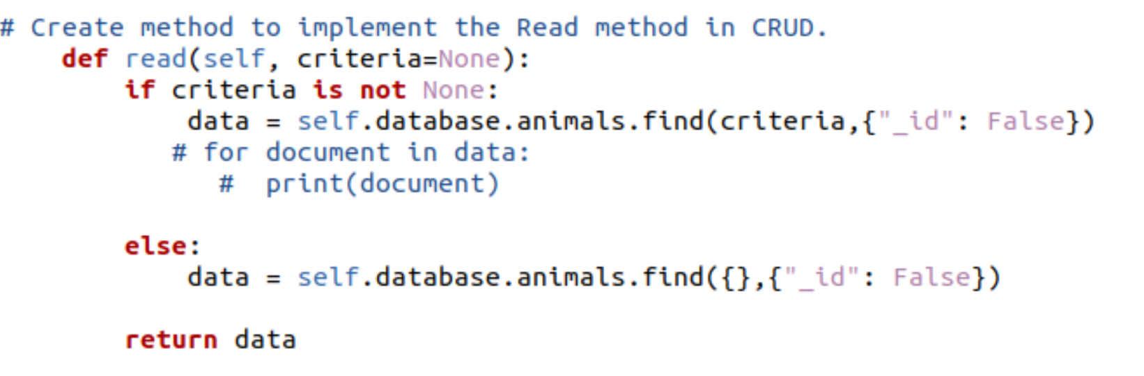

Update method that queries for and changes document(s) from a specified MongoDB database (“AAC”) and specified collection (“animals”). Input should also be key/value pair. Last argument of function will be key/values pairs in the data type acceptable by MongoDB driver insert API call. Return result in JSON format if successful, else error message.

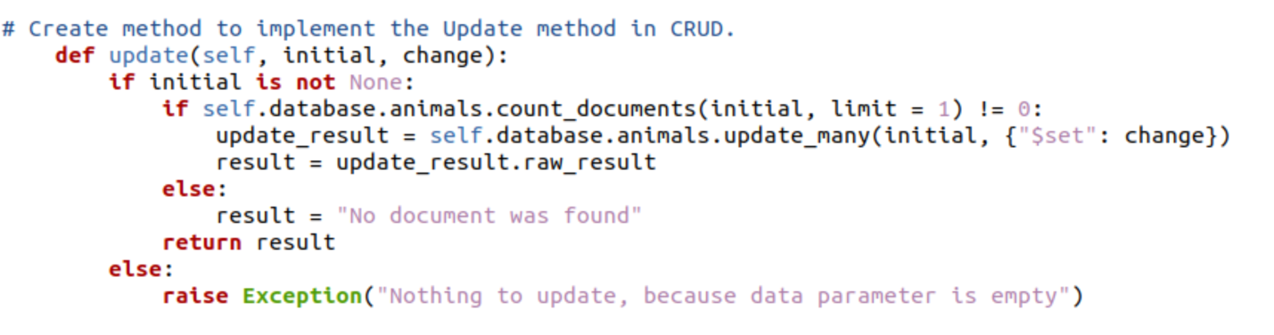

Delete method that queries for and removes document(s) from a specified MongoDB database (“AAC”) and specified collection (“animals”). Input should be key/value look pair. Return result in JSON format, else returned error message

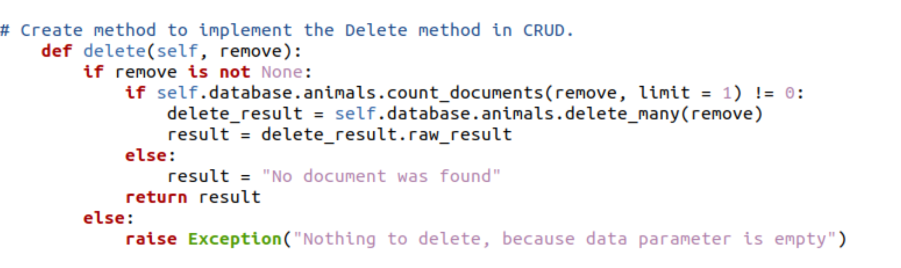

**Dashboard w/ Execution Screenshots**

The final portion of the project includes the interactive dashboard. This section includes examples and screenshots from the end-user or client-side of the application. The dashboard provides different features the allows the user to sort the columns, filter the results based on the 4 widgets: Reset (which clears the filter), Water Rescue, Mountain Rescue, and Disaster Rescue. When the different widgets are selected the map is updated and bar graph are updated to match the specific filter. The user can also interact with the map, zoom in and out, and move the cursor around. When an animal is selected, it is pinned to the map based on the longitude and latitude. This feature is provided by Leaflet which renders the interactive map. Dash is a popular framework for creating data visualization interfaces in Python. This library offers a variety of features for building dashboards within a browser. Dash consists of two segments which include the layout of the application, and the other portion illustrates the interactivity of the application (*Dash Framework,* n.d.).

**Dashboard Full Screen**

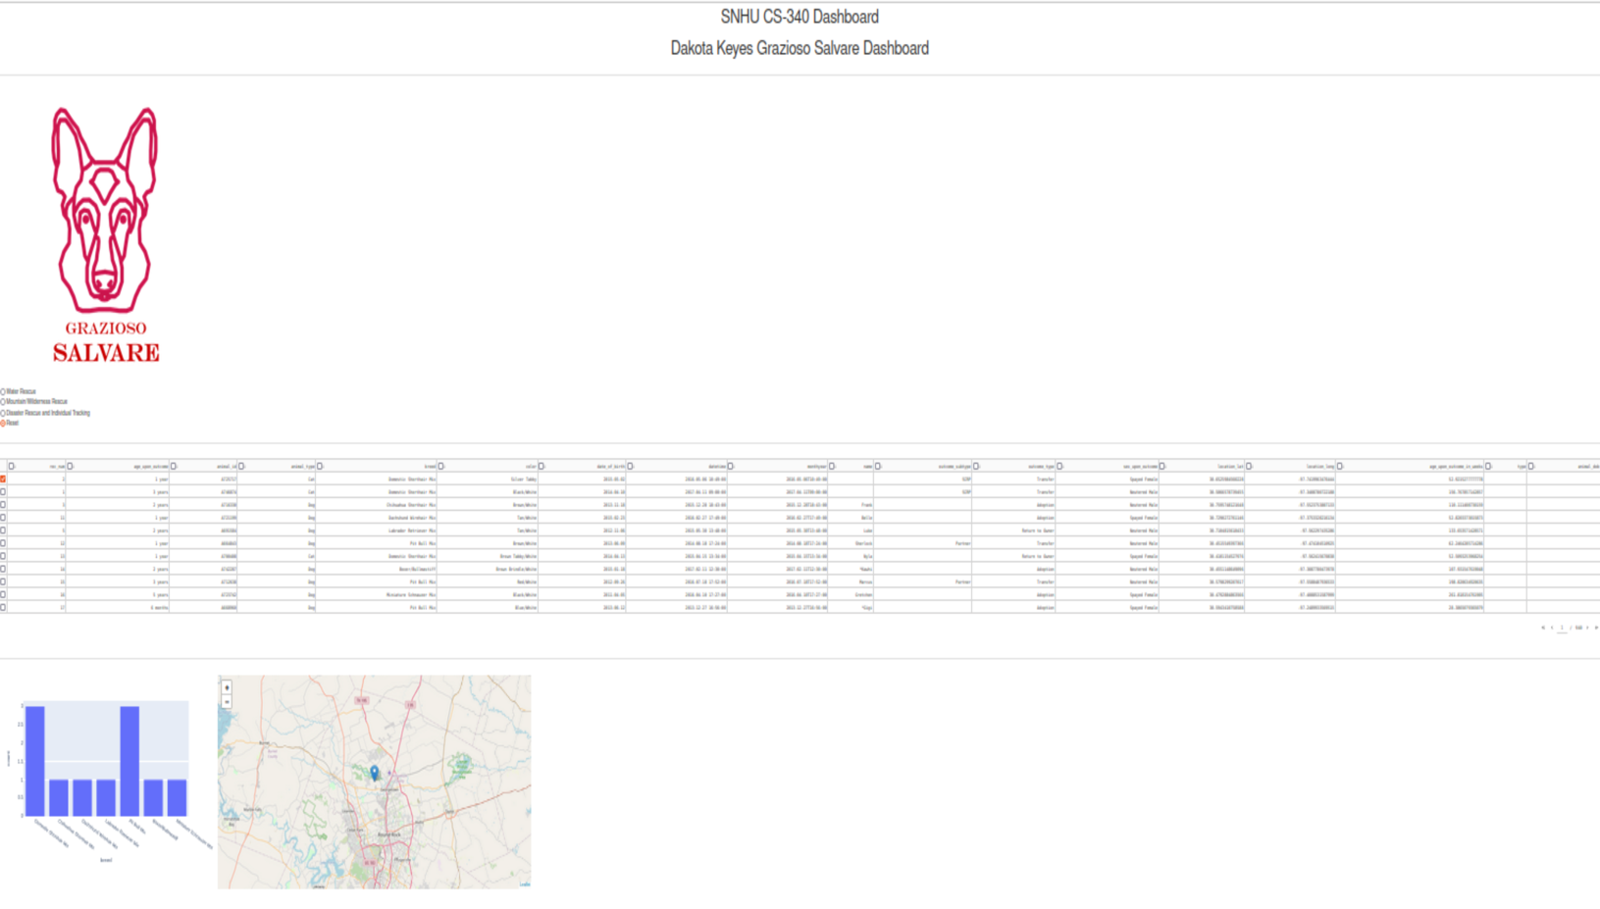

**Water Rescue (was very hard to see the table when zoomed out for header to be included)**

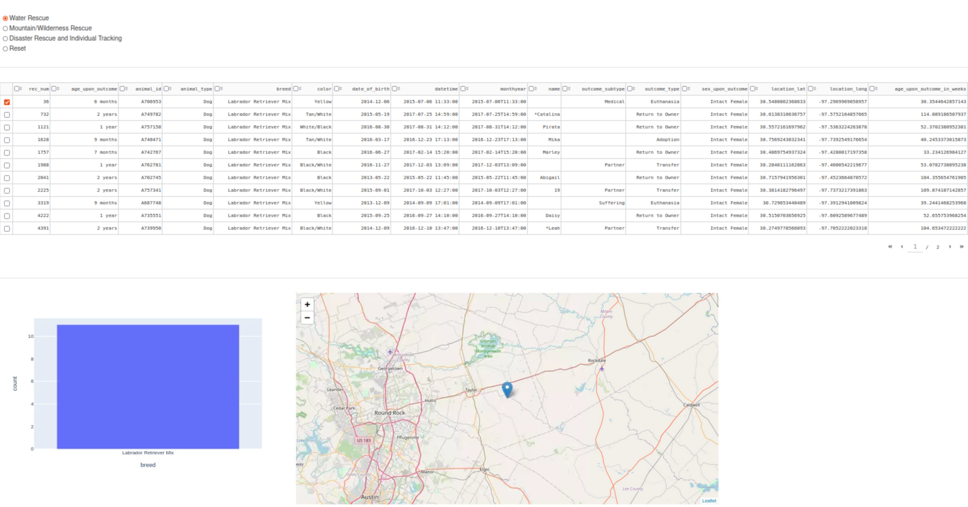

**Mountain Rescue**

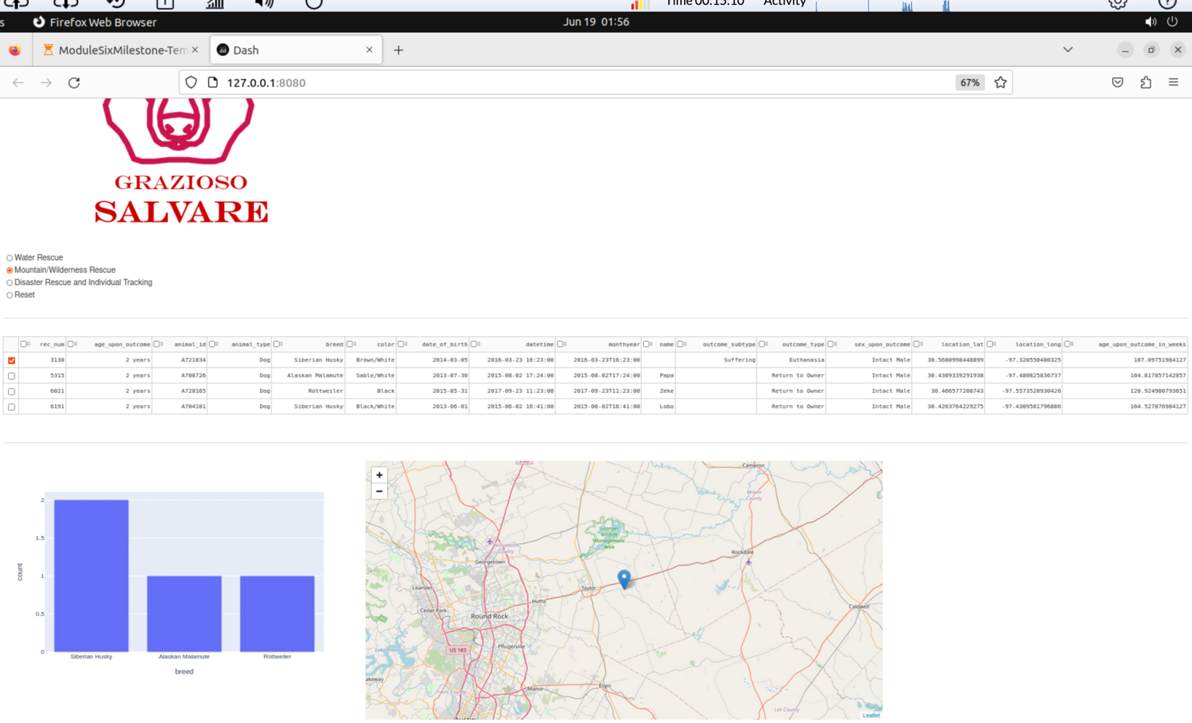

**Disaster Rescue**

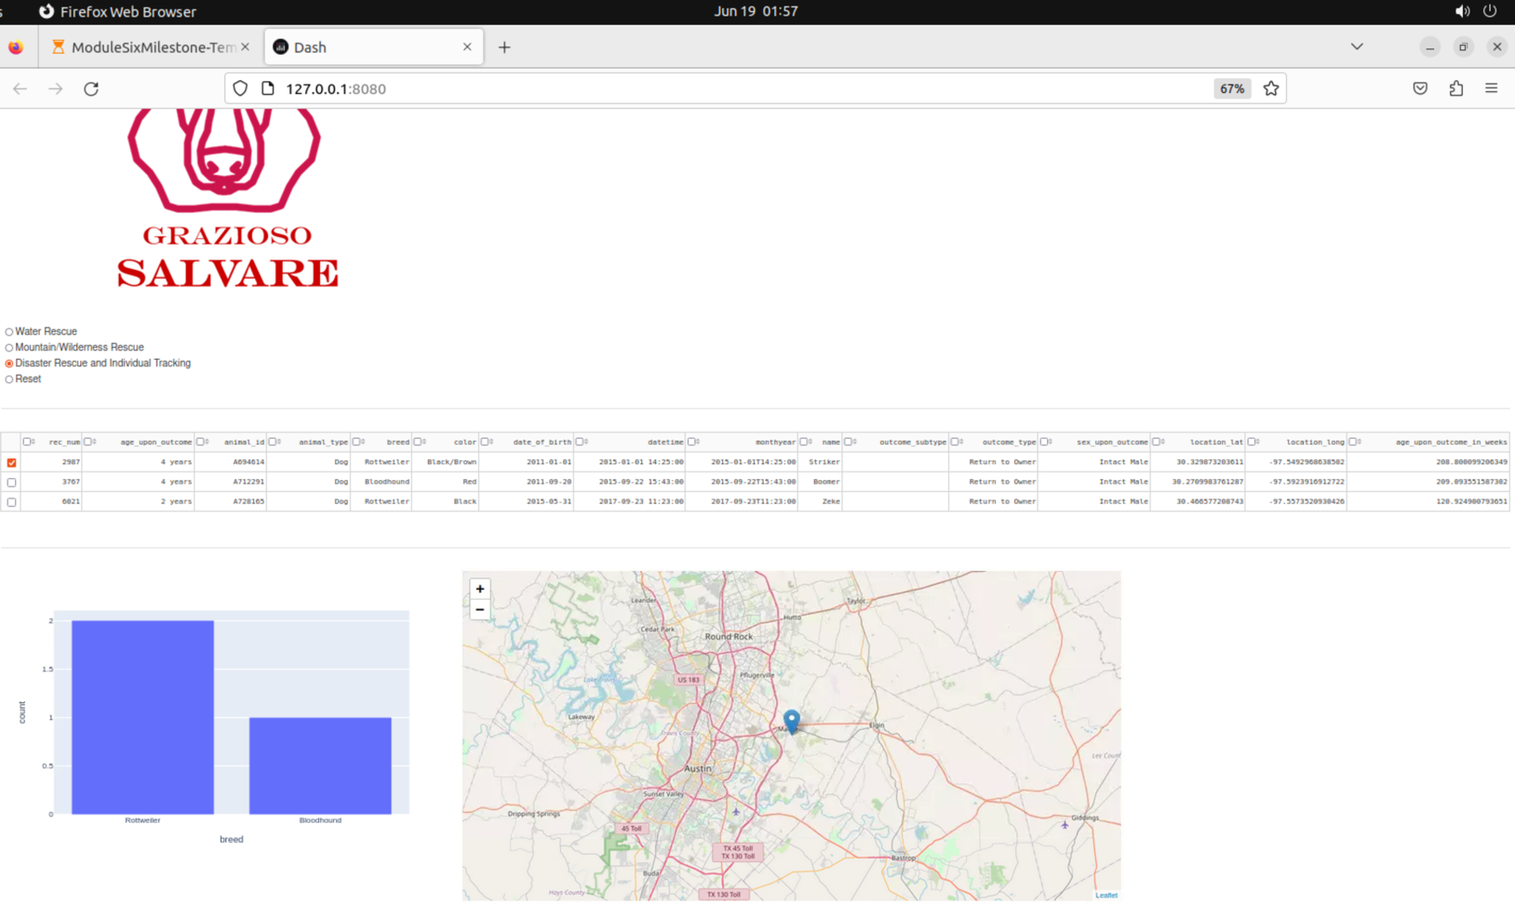

**Reset Filter**

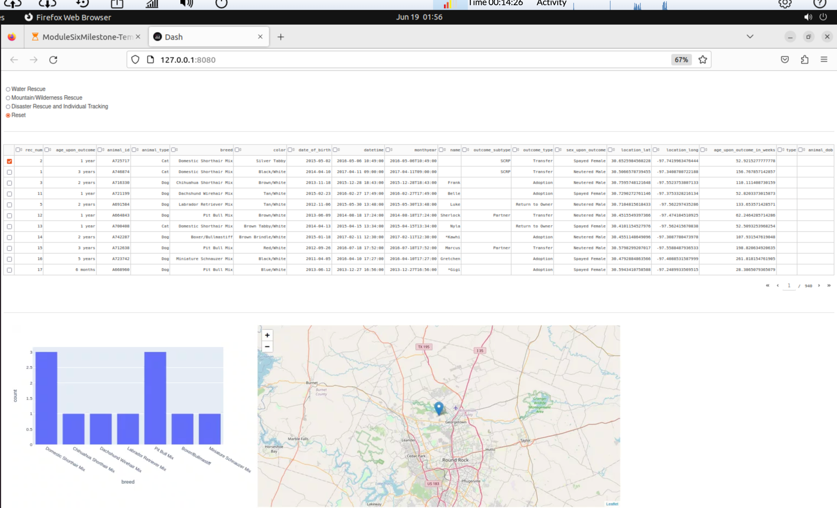

### Testing

For testing, I included a raise exception in the Create method in CRUD.py

**Testing invalid document for raised exception.**

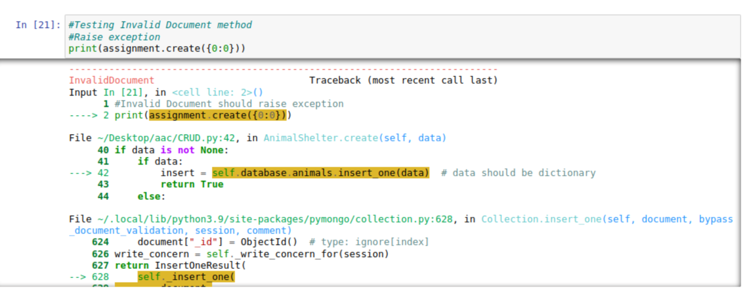

Valid & Invalid Read Method

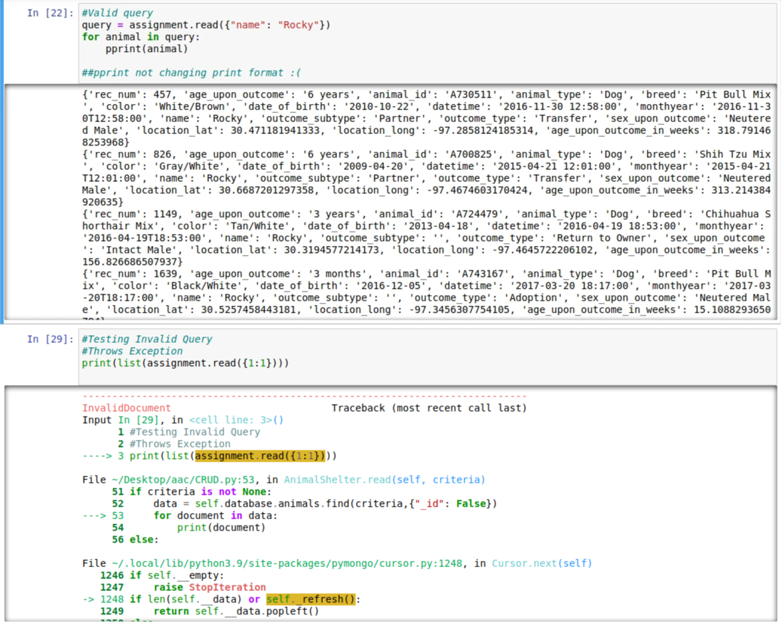

### First screenshot shows valid read method while the second shows invalid query with raised exception.

**Testing CRUD**

**Create Method**

**Valid**

This method creates a data dictionary, with a test dictionary to ensure that the CRUD.py file create method is working correctly. This snippet correctly inserts a document into the specified database “aac” and must include the username and password to access the MongoDB.

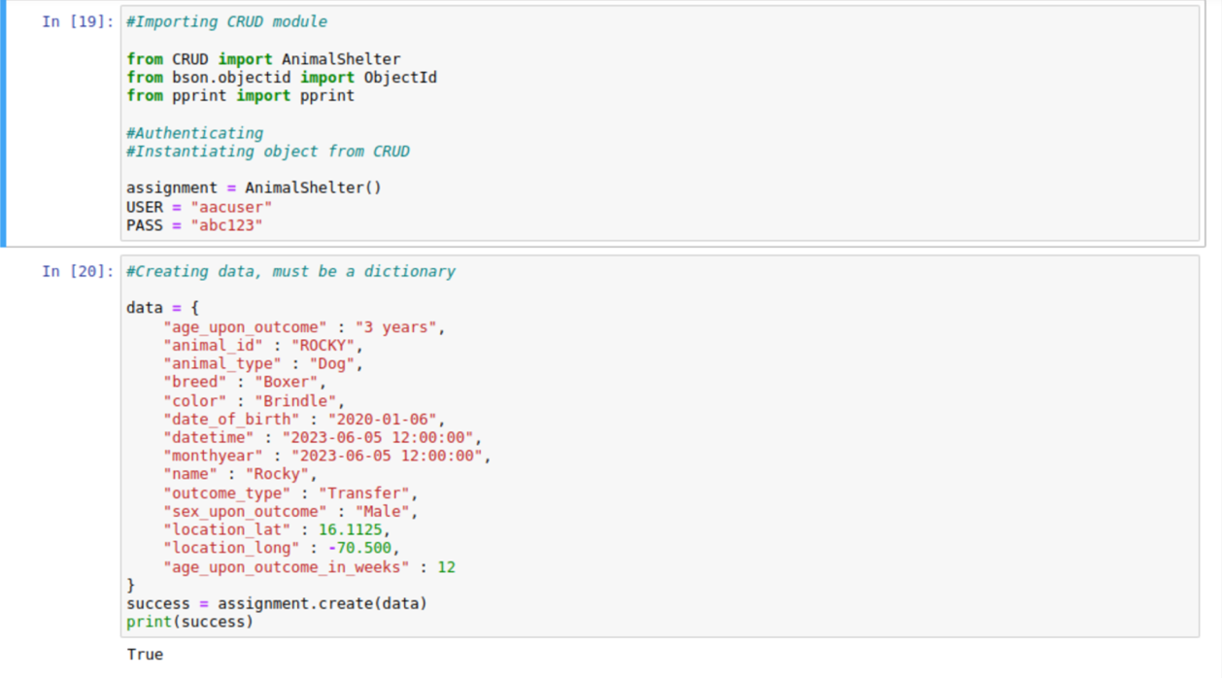

**Invalid Thrown Exception**

Testing verification that shows the exception for invalid insertion.

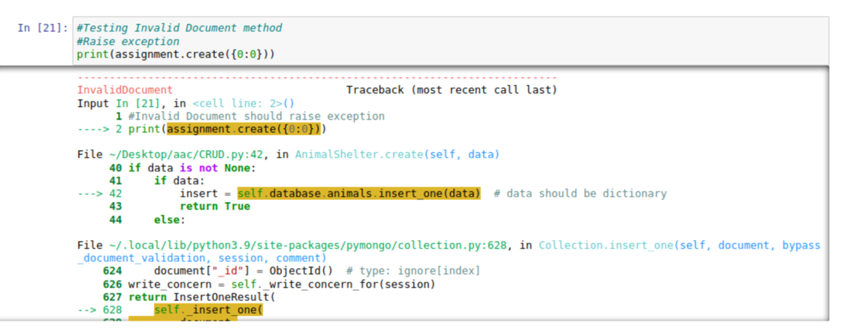

**Read Method**

**Valid and Invalid with Thrown Exception**

The read method queries for document(s) from a specified DB “aac” and specified collection “animals”.

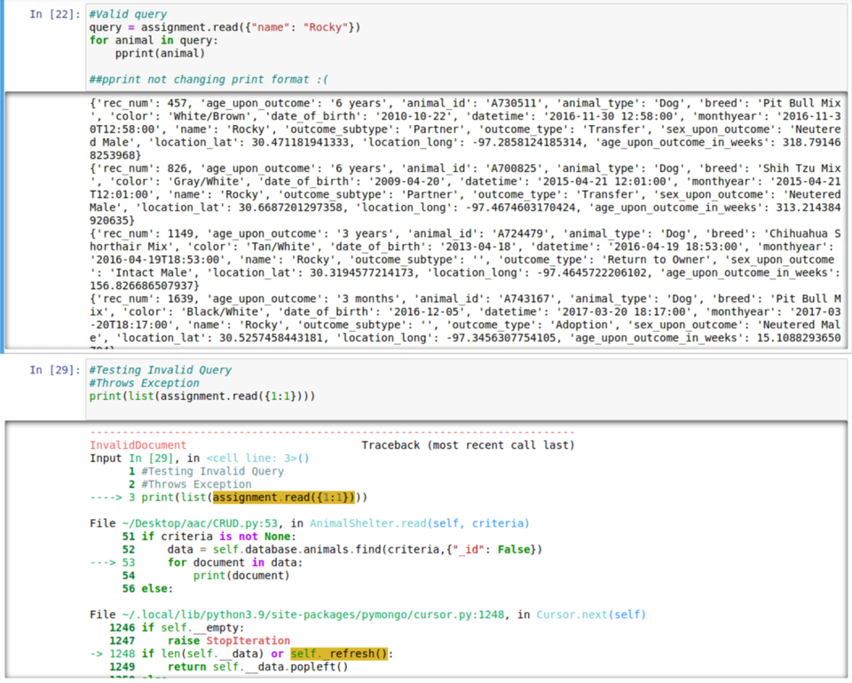

**Valid Update Method**

Valid update method that queries for and changes documents from a specified MongoDB and collection. The update method input must have the key/value lookup pair ({“name”: “Rocky}, {“outcome_type”: “Found”})

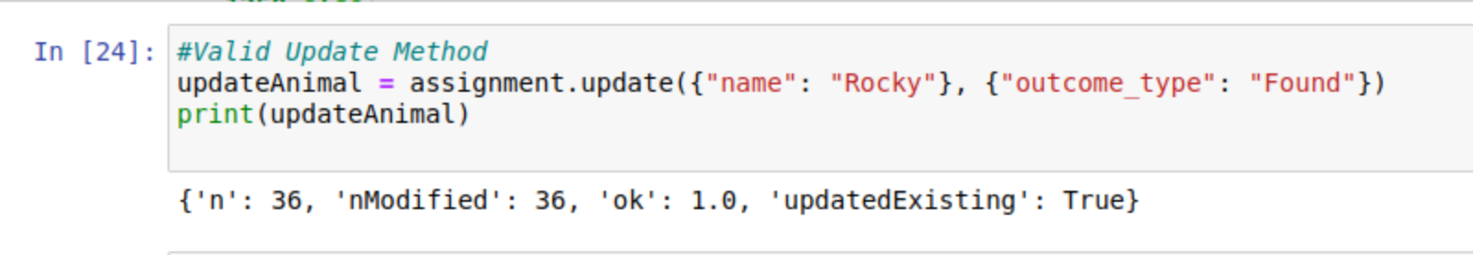

**Invalid Update Method with Thrown Exception**

Invalid update method that is missing the positional argument (ie the change).

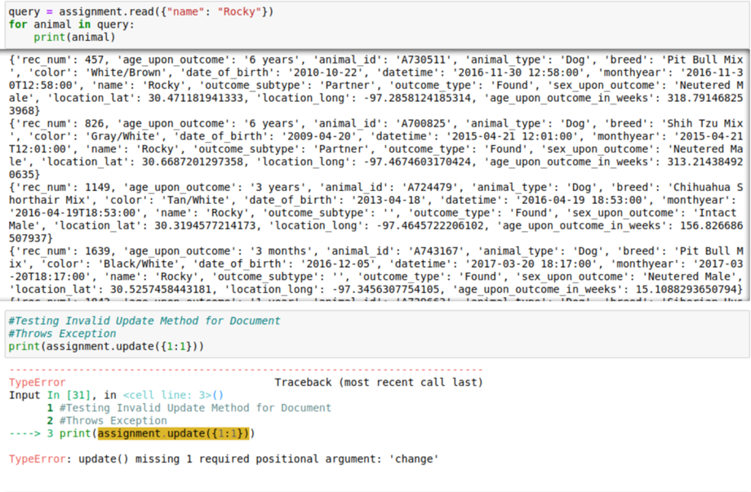

**Valid Delete Method**

Valid delete method that queries for and removes document(s) from “aac” collection “animals”.

Once again, to delete, there has to be a specified key/value pair in order to properly delete from the document. In this example the key/value lookup pair is ({“name”: “Rocky”})

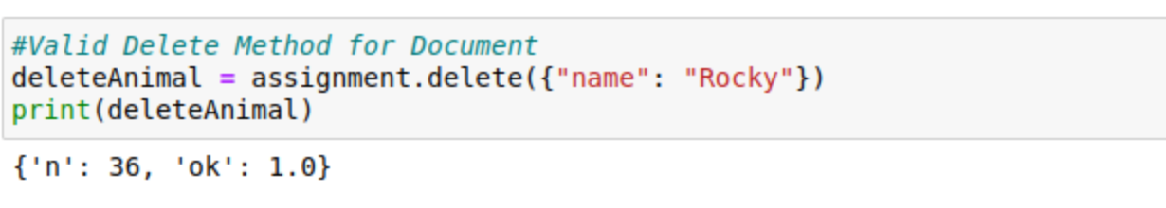

**Challenges**

There were many challenges that I encountered during this project. I had trouble creating the admin and aacuser into the database with the correct roles. I had to delete both the users and recreate them with the correct roles within the AAC database. I struggled with creating the CRUD module, specifically the Create and Read method. After I established connection and figured out how to implement these methods in the Jupyter notebook, the Update and Delete method were much simpler. I had a difficult time with the Client-Side Authentication assignment and took me a while until I finally was able to login with the correct credentials and query the correct results. With the dashboard, I struggled with the interactive graph, and sorting the table. The widgets were confusing as well. Overall, this was a very difficult and time-consuming project. I have never interacted with any databases while coding, so most of this project was all new information and concepts that I was unfamiliar with.

## Contact

Dakota Keyes

**References**

Bruce, D. (2021). Understanding the Pros and Cons of MongoDB. *Knowledgenile*. <https://www.knowledgenile.com/blogs/pros-and-cons-of-mongodb/>

*Dash Framework*. (n.d.). https://www.tutorialspoint.com/python_web_development_libraries/python_web_development_libraries_dash_framework.htm

Ramos, A. R. (2023). Python and MongoDB: Connecting to NoSQL Databases. *realpython.com*. <https://realpython.com/introduction-to-mongodb-and-python/#:~:text=In%20general%2C%20PyMongo%20provides%20a,data%2C%20and%20run%20database%20commands>.

Team, T. (2021). Python Advantages and Disadvantages – Step in the right direction. *TechVidvan*. https://techvidvan.com/tutorials/python-advantages-and-disadvantages/